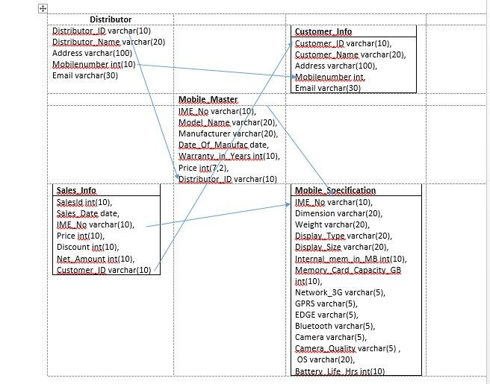

1. Write a Query to Display the mobile details such as IMENO, ModelName,Manufacturer produced by the manufacturer Nokia.

Select IMENO,ModelName,Manufacturer from Mobile_Master where manufacturer =” Nokia”;

1. Write a Query to display IMENO, ModelName, Manufacturer, Camera Quality of mobiles whose camera quality is 5MP.

Select mo.imeno, mo.modelname ,mo.manufacturer , f.camera_quality from mobile_master mo , mobile_specification f where mo.imeno=f.imeno and f.camera_quality=”5MP”;

1. Write a Query to display the distributor details such as distributor name,mobile number and email of the Mobile model 'MicromaxQ5'.

Select d.distributor_ name,d.mobilenumber,c.email, s.custmer_id,ms.imeno

From distributer d,customer_info c,sales_info s,mobile_specification ms where s.email=d.email and mobile_model =” MicromaxQ5”

1. Write a Query to display mobile model, manufacturer and price for the mobiles having a price range from 8500 to 25300

Select mobile_model,manufacturer ,price where price having between(8500,25300)

1. Write a Query to display the IMENO,model name,manufacturer,price and discount of all mobiles regardless of whether the mobile is sold or not.

Select m. imeno,modelname,m.manufactuere ,m.price ,s.discount,ms.imeno from mobile_master m mobile_specification ms,sales_info s where s.imeno=m.imeno;